Searching and Exporting (Supplier)

Searching for a proposal
By clicking ‘View all proposals’ on the dashboard, you will be taken to the proposals list.

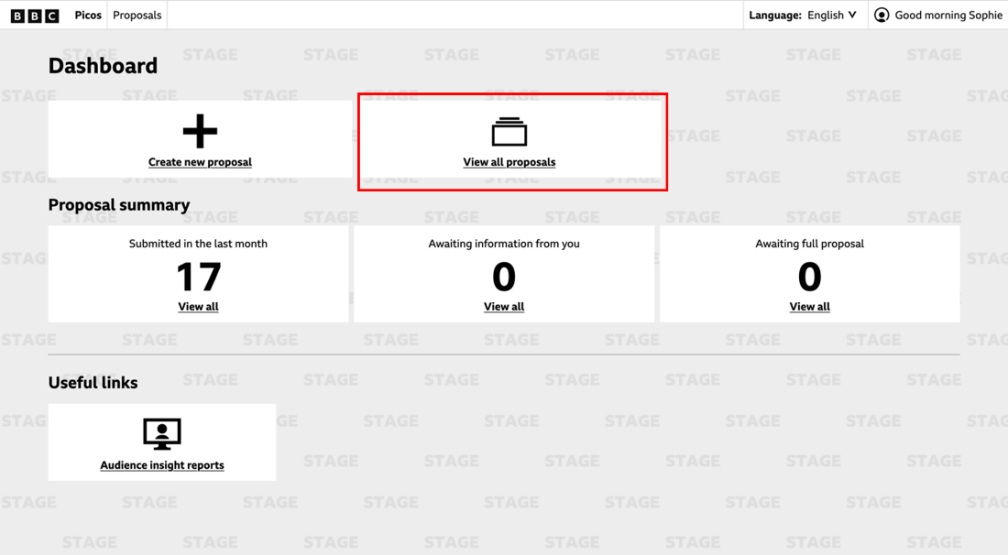

This will initially show all the proposals created by you. By changing the ‘Created by Me’ filter, you can select to view all proposals by your production company. You can also filter by proposal status (e.g. approved or rejected), commissioning group, rounds and briefs, and who it is assigned to.

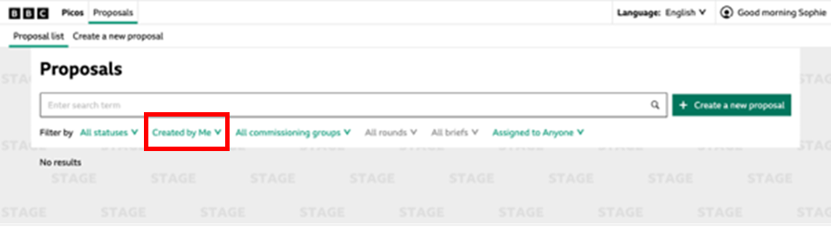

Exporting a proposal
From the ‘Proposals’ page, you can export a proposal by clicking the three dots to the right. This will download the proposal as a CSV file.
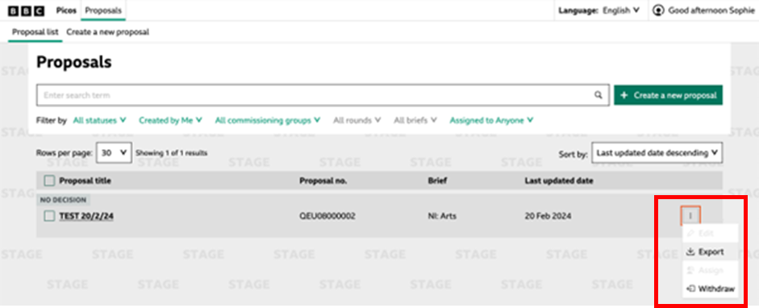

You can select multiple files and click ‘Export’ in the bottom right corner of the screen to download multiple proposals at once as a CSV file.

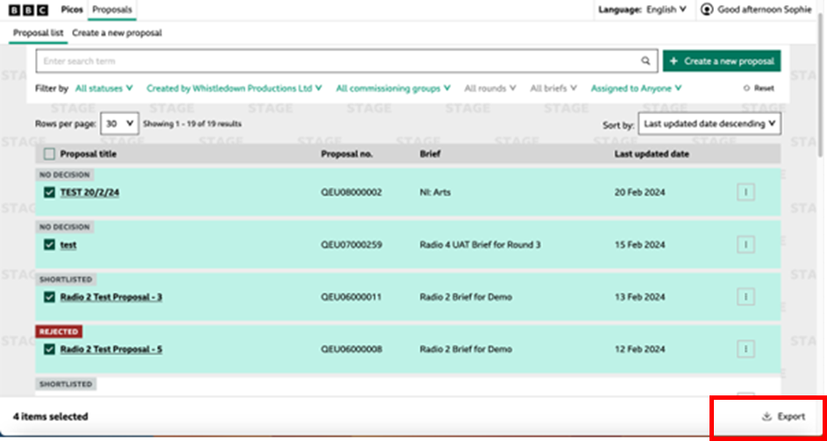

You can also export as a CSV by clicking on the proposal and then going to the three vertical dots to the top right of the proposal.

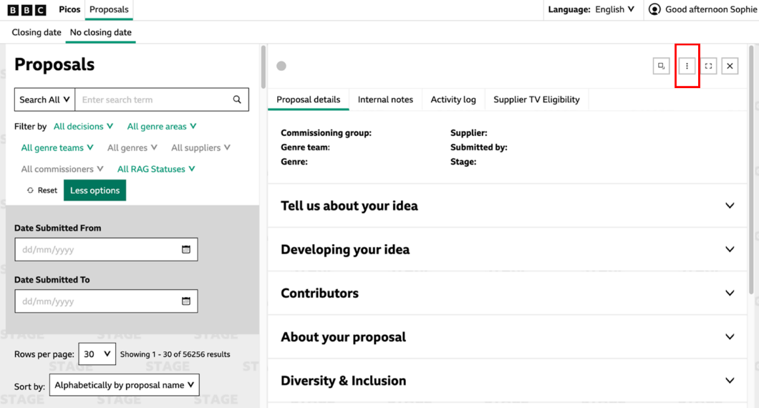
To save an individual proposal as a PDF, you can select ‘Print’ through your browser. This will take you to the print screen, where you can either print it off or save as a pdf file.

