

Proteus: Indie Proposal Submission Guide
Document History
Version | Date | Author | Comment
2.0 | 05/07/2019 | Lucy Walters | Updated Formatting
2.1 | 04/11/2019 | Lucy Walters | Updated to reflect current processes
2.2 | 18/01/2022 | Kelly Payne | Updates to D&I information
2.3 | 01/03/2023 | Shiromi Ramanayake | Updated to reflect current processes
Contents
1 Introduction 2
2 Submitting Proposals 3
2. 1 Accessing Proteus for Pitching 3
2.2 Forgotten Password 4
2.3 Changing your password 6
3 Creating Proposal 8
3.1 Save Your Proposal 11
4 Submit the Proposal 11
4.1 Submitting Individual Proposals 12
4.2 Submitting Multiple Proposals 12
5 Proposal Status Guide 15
6 Searching for Existing Proposals 15
6.1 Personalise the Search Screen 17
6.2 Customise Search Results 18
7 Edit a Proposal after Submission 20
8 Delete a Proposal 20
9 Printing 20
9.1 Print an Individual Proposal 20
9.2 Print Multiple Proposals 21
10 Proposal Reports 23
11 Commissioning Round Results 23
12 Proposal Budget 24
13 Logging Out 24
14 Support 25

1 Introduction
Proteus is a web based system managed and developed by the BBC.
Radio in-house production and independent programme suppliers use Proteus to create and submit programme ideas, complete compliance and programme descriptions, create running orders and submit music reporting.
Users in BBC network management areas access the system to commission programme ideas, create programme schedules, support playout and generate reports. The system is also used by BBC finance areas to track programme costs and support financial forecasting.
Here are the Spring 2023 statistics regarding the amount of Proteus user accounts:
BBC Users: 2,242 users
Indie Users: 1,969 users
Indie Production companies: 955

To find out more about Proteus, how to apply for a login as an Indie and what forms you need to fill in, please click on this link:
https://www.bbc.co.uk/academy/proteus/whats-proteus/
General information about the BBC Radio Commissioning process can be found here:
https://www.bbc.co.uk/commissioning/radio/how-we-commission/
https://www.bbc.co.uk/commissioning/radio/pitching-ideas/
All of network radio’s programme paperwork is managed through Proteus. If you need to know how to complete programme descriptions, compliance, running orders and music reporting, you will need to access the Proteus training materials on the Academy website.
For those who have already attended the training and require a refresher, online video support for programme paperwork can be found here:
http://downloads.bbc.co.uk/academy/academyfiles/Indie_%20Proteus_production_guide.pdf

2 Submitting Proposals
Before accessing Proteus, you must sign up to the BBC Radio Independent Production Company database. For more information, please see link below:
https://www.bbc.co.uk/commissioning/radio/commissioners/becoming-a-supplier/
Your production company will then be assigned a generic company Pitching account. This will enable you to submit programme proposals in the system.
https://www.bbc.co.uk/commissioning/radio/commissioners/submitting-a-proposal/
A separate login will be issued to individual users who need to submit paperwork for commissioned programmes.
To submit a proposal:
Independent companies who only need to access Proteus to submit programme ideas should access Proteus via the website address below, using their generic company login (ending “00”) which provides restricted access to Proteus:
https://proteus-pitching.tools.bbc.co.uk
To complete paperwork:
Independents wishing to manage programme paperwork for commissioned programmes (and who also wish to submit programme ideas) can use their individual account to log in via the following Proteus website:
https://proteus-external.tools.bbc.co.uk
WARNING: Proteus should be used with the latest version of either Microsoft Edge or Google Chrome on either MAC or Windows PC to ensure correct functionality.

2. 1 Accessing Proteus for Pitching
Use the following link to log in: https://proteus-pitching.tools.bbc.co.uk
Enter the generic company username (ending “00”). If you have pitching access added to your individual username (ending in 01, 02, 03 etc.), you can use that to log in to pitch.
Enter password.
Click “Login” (or press Enter on the keyboard).
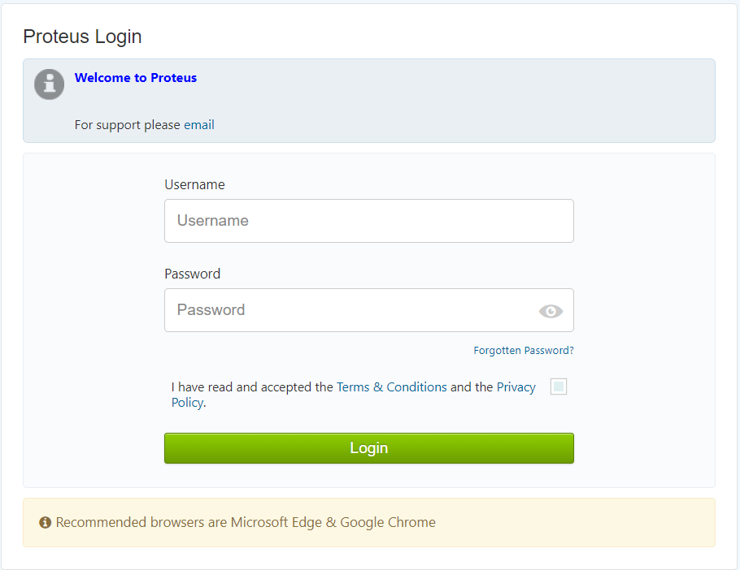
TIP: Click on the grey eye symbol (on the right hand of the Password field) to check the password you have entered is correct:

2.2 Forgotten Password
If you have forgotten your password you can reset it from the login page. On the login page, click the “Forgotten Password” link (located above the green Login button):
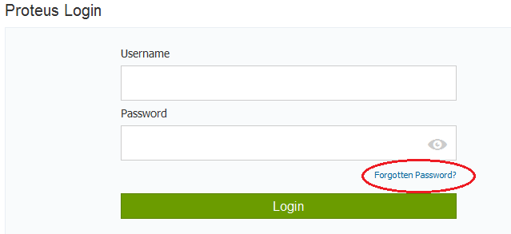

Enter your username, follow the instructions and tick the relevant boxes: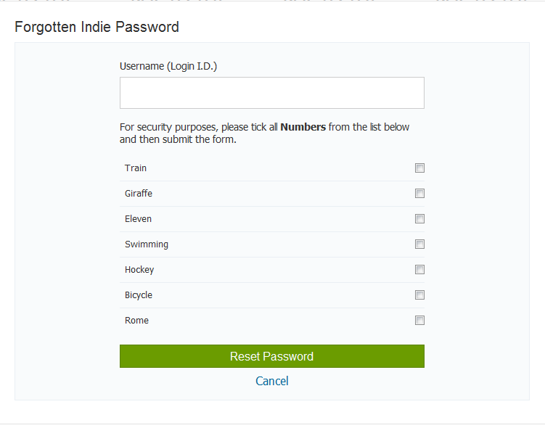
Click “Reset Password”.
The following screen will be displayed:
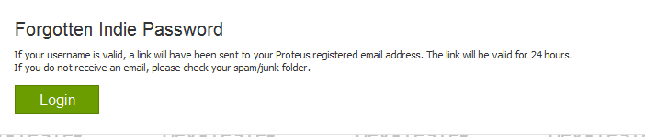

An email containing a “Reset Password” link will automatically be sent to your Proteus registered email address within 30 minutes.
Click on the link and the following screen will be displayed:
Follow the instructions to reset your password.
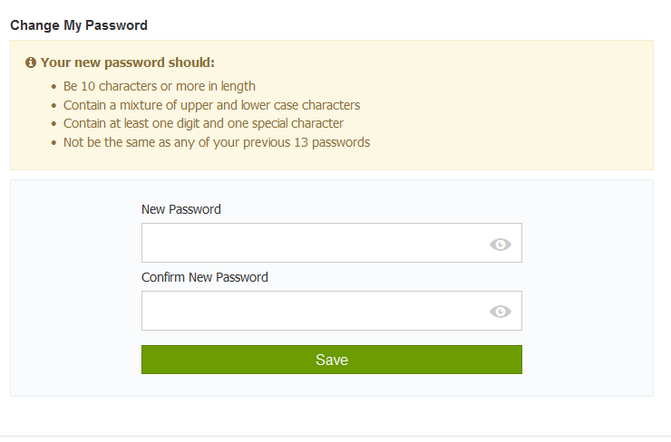
TIP: Click on the grey eye symbol (on the right hand of the Password field) to check the password you have entered is correct:
Press “Save”.
The following message will be displayed:
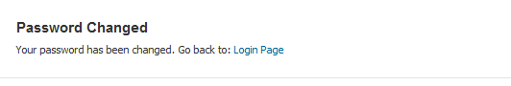
WARNING: You can only reset your password once in a 24 hour time period.

2.3 Changing your password
Once you have logged into Proteus with your current password, you can change it at any time.
Click on your username (located on the top menu bar, on the far right hand side).
Click “Change My Password”:
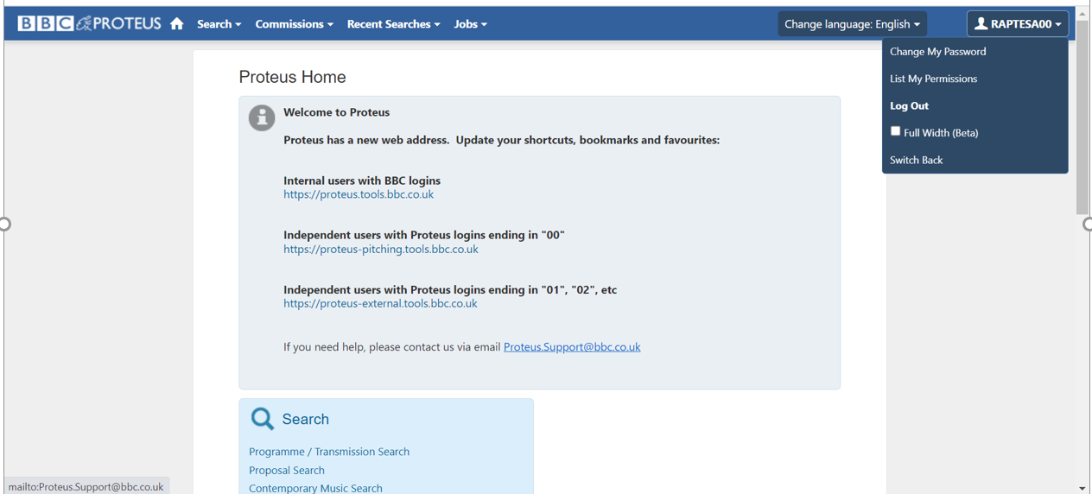
Follow the instructions to create a password.
TIP: Click on the grey eye symbol (on the right hand of the Password field) to check the password you have entered is correct:
Click “Save”:
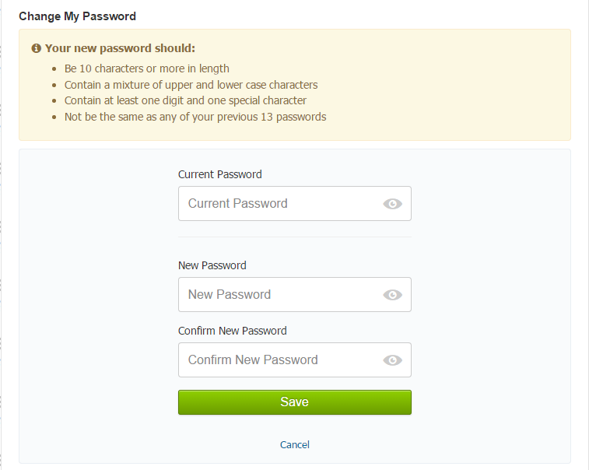
The following message will be displayed:
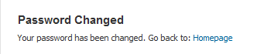

3 Creating Proposal
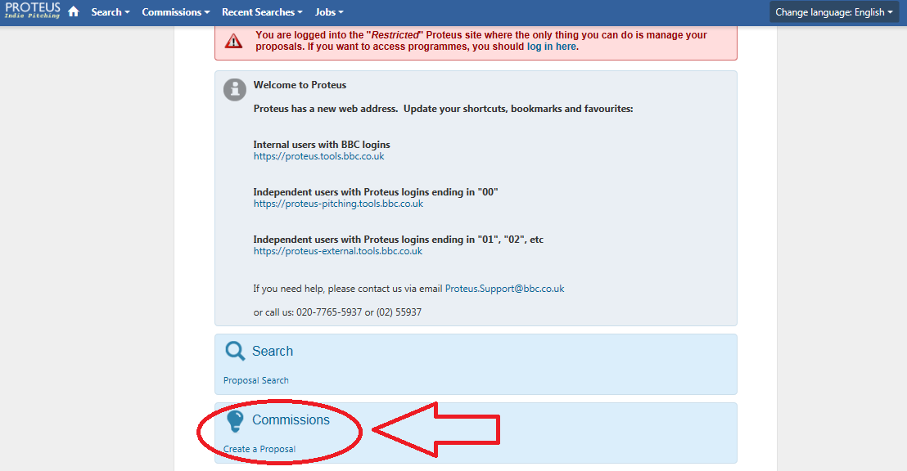
In order to create your proposal, you will need to click on “Create a Proposal” from the home page, in the “Commissions” section.

The “Create Proposal” screen will then be displayed:
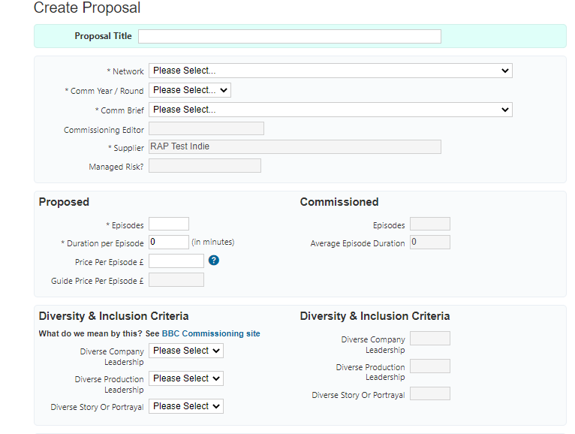
First, you have the option to enter the minimum amount of required data into the proposal and save this as a draft. The title and the fields marked with an asterisk are all required.
By doing this you can ensure that should any issues occur with the proposal while you are adding the descriptions, you will have saved the basic proposal.
The fields are filled in as follows:
Network: Click to reveal a list of the Networks that have a current “Commissioning Round” open. Select the correct Network.
Comm Year / Round: Click to select the correct “Commissioning Year and Round”.
Comm Brief: Click to select the correct “Commissioning Brief”.
WARNING: The network must be selected first in order to display the options available in the “Comm Year/Round” and “Comm Brief” fields. If the expected brief is not visible, please contact the network.

Numbers: Enter as whole numbers with no decimal points.
Dates: Enter date in the following format: DD/MM/YYYY
Price per Episode: Enter a figure here if you wish to propose a figure which is different from the guide price.
Guide Price per Episode: Filled in by the Network.
Diverse Company Leadership – Select ‘Not Known’, ‘Yes’ or ‘No’ from the dropdown to indicate whether your company leadership meets this criterion.
Diverse Production Leadership - Select ‘Not Known’, ‘Yes’ or ‘No’ from the dropdown to indicate whether your production team leadership meets this criterion.
Diverse Story or Portrayal - Select ‘Not Known’, ‘Yes’ or ‘No’ from the dropdown to indicate whether your story or portrayal meet this criterion.
You can find information about the BBC’s Diversity & Inclusion criteria on the BBC Commissioning site (follow the blue hyperlink above the D&I fields).

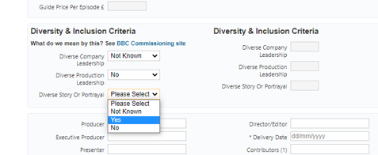
Add / Edit Notes Here section: Information entered here is sent to the network. You may also add any comments you wish to send to the commissioners which do not fit appropriately in any of the other fields.
Any questions relating to BBC Editorial Guidelines should be addressed to the relevant network compliance editor.
Private Notes section: Information entered here is NOT submitted to the network or visible to the network at any point. If required, this field is provided for you to make notes on your proposal.
Synopsis: The short synopsis and full synopsis fields are at the bottom of the form.
Refer to the “Commissioning Guidelines/Brief” document issued by the relevant network to find out exactly what they require and what their word limits are (these may vary between networks).
Diversity & Inclusion
This is your opportunity to tell us how your proposal meets the BBC’s criteria for diverse stories and portrayals. You can find out more by following the blue hyperlink on the proposal form, entitled ‘BBC Commissioning Site’. Please note that this text field relates to Diverse stories and portrayals only and should not include any information about individuals.
Multimedia Ideas section: Entering information here is optional. Refer to the relevant network “Commissioning Guidelines” document or contact the network to discuss.

3.1 Save Your Proposal
Once all the mandatory fields have been filled in, it is possible to click the “Save as Draft” button (located at the bottom of the form) and return later to complete.
You will need to “Search” for the proposal again (see Search for Existing Proposal section).
You can also navigate back to your draft proposal through the “Recently Viewed” section on your homepage:
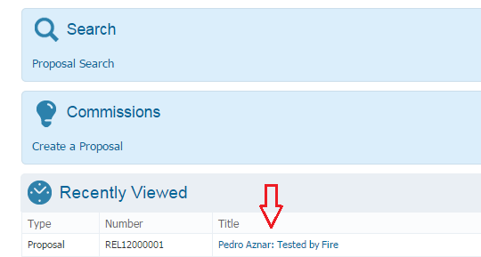
Once you have found your proposal, click “Edit”, located on left hand side of search results to resume entering proposal information.
When the proposal has been completed, scroll to the bottom and click “Save as Draft”.
It may take a short while to save. Please do not click away during the save action.
WARNING: The proposal has not been submitted to the Network at this point.

Once a proposal has been saved, it will automatically generate a “Proposal Number”, visible at the top of the proposal. You can also use this proposal number to search for your proposal instead of entering the title.

4 Submit the Proposal
This section explains how to individually submit a proposal to a network. It also shows you how to batch submit multiple proposals.

4.1 Submitting Individual Proposals
First, you will need to search for your proposal, or locate it through your “Recently Viewed” section on your home page.
The status of the proposal will be “Departmental”.
The proposal can still be edited.
WARNING: The proposal has not been submitted to the Network at this point.

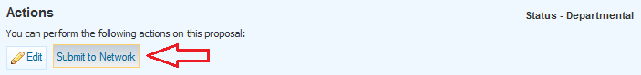
Check the proposal over and when satisfied it is complete, scroll to the bottom and click “Submit to Network”:

The status of the proposal will change to “Network Received”.
The proposal can no longer be edited. It can only be viewed.
However, under certain circumstances the network may re-set the status of the proposal to “Re-Request”, so it can be edited by the supplier and re-submitted to the network.
Proteus will send an automated email receipt to your Proteus registered email address. This can take up to 30 minutes after you have clicked “Submit to Network”. It is possible that your email spam filter may place Proteus automated emails in your junk/spam folder.
WARNING: It is your responsibility to ensure that your Proteus registered email address (located top right of the screen) is correct and kept up to date. Update this information by contacting the Proteus Team. Email: proteus.support@bbc.co.uk

4.2 Submitting Multiple Proposals
If there are multiple proposals for a particular “Commissioning Round”, it is possible to submit them together.
From the homepage, select “Proposal Search” from the available options.
From the “Proposal Status” field options, select “Departmental”.
Select the relevant Network. You may also wish to filter on “Commissioning Year” and “Commissioning Round”.
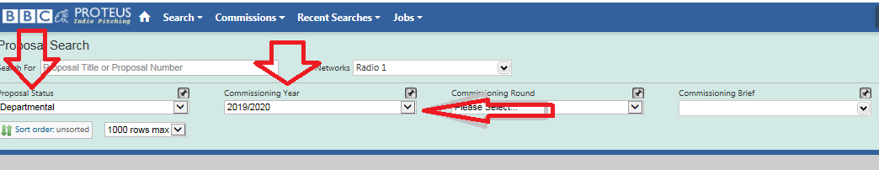
The search results will look similar to the list below:
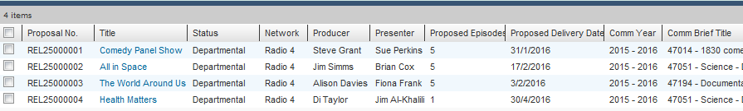
Click the tick box located on the top left hand side to select (or deselect) all proposals.
Alternatively, you can tick (or untick) individual proposals:
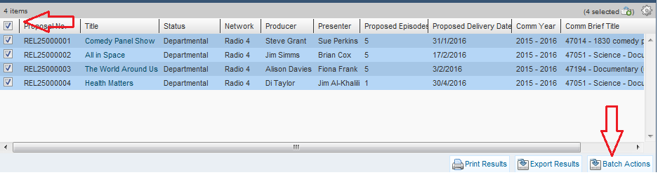
Click the “Batch Actions” button, located at the bottom right of the screen:
WARNING: The proposals have not been submitted to the Network at this point.

The “Batch Process Options” screen will be displayed.
This page allows a number of different actions to be applied to a group of selected Proposals.
For example, if you select the option to “Change Department to Network”, then click “Continue”, it will submit the proposals you selected on the previous screen to Network.
WARNING: Please note that the proposals you have ticked on the previous screen are the ones you want to submit to the network. It is not possible to cancel the Batch change/submit action once the Continue button has been clicked. Once you have clicked Continue, the action cannot be reversed.

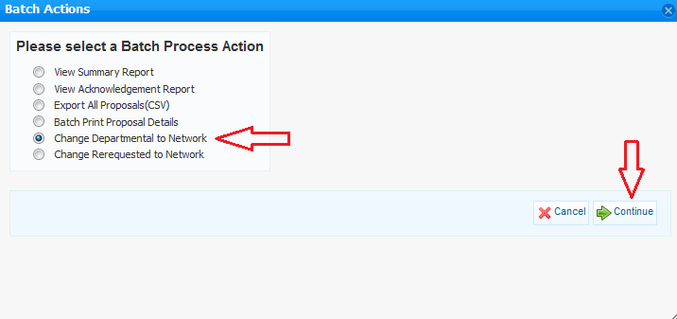
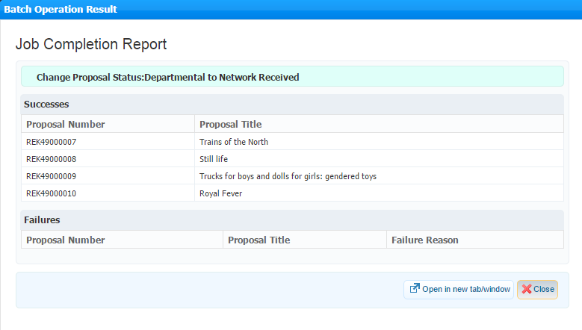
After clicking “Continue”, a “Job Completion Report” will be displayed:

Click “Close” to shut the pop-up message.
The Network will consider the proposal(s).
The relevant Network’s “Commissioning Guidelines/Brief” document may include a date when the proposal results are available in Proteus to view.
Alternatively, you can run Proteus “Proposal Searches” regularly to see whether the network has changed the status of the proposal(s), and added any feedback notes.
Refer to the “Commissioning Round Results” section of this guide.

5 Proposal Status Guide
Status | Definition | Who can edit / change the status?
Departmental | A proposal has been created and saved, but not yet submitted. It is still effectively a draft. | Anyone with access to the company generic login account or anyone with a unique personal company login.
Network Received | The proposal has been submitted to the network for their consideration. | Only the commissioning network can change its status. If they need to amend the proposal they have to send it back to Re-Request for the supplier to amend it.
Shortlisted | The network has earmarked the proposal for closer attention. | Only the commissioning network can change the status.
Re-Request | The network has received the proposal but something in it needs to be amended, so they have set it to Re-Request. | As per Departmental  (see above).
Rejected | The network has decided not to commission the programme(s). | Only the commissioning network can change the status.
Conditional Commission | Has been commissioned by the network (pending budgetary and contractual arrangements). | Only the commissioning network can change the status.
Conditional Pilot Commission | A pilot has been commissioned by the network (pending budgetary and contractual arrangements). | Only the commissioning network can change the status.
Commission Suspended | The commission has been suspended. | Only the commissioning network can change the status.
Commission Cancelled | The commission has been cancelled. | Only the commissioning network can change the status.

6 Searching for Existing Proposals
From the Home page, you can either click “Proposal Search” in the light blue panel or click “Search” on the top blue bar:
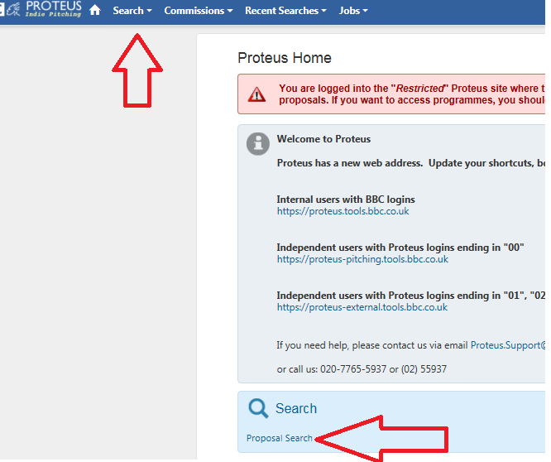
You can return to the homepage at any time by clicking on the “Home” icon:
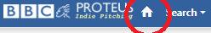
On the homepage, click “Proposal Search”.
This will display the “Proposal Search” screen.
You can search for a specific proposal title very quickly by entering a partial or complete title into the field on the left hand side.
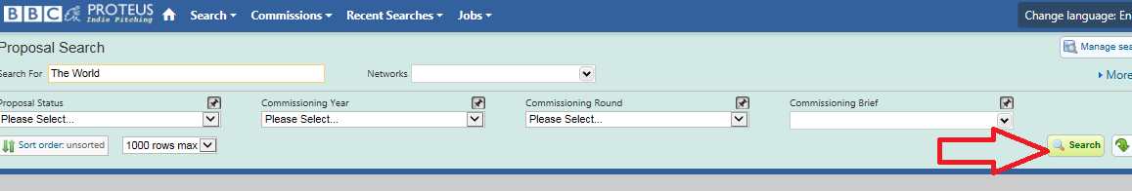
You can also select a network to help filter the data.
Click “Search” or press the “Enter” key on the keyboard:
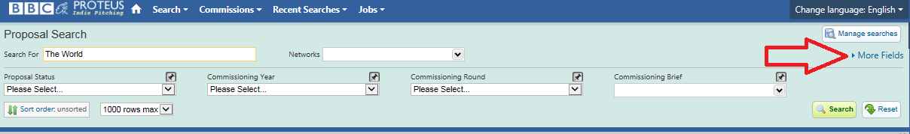
To complete a more detailed search (e.g. to display proposal results for a particular round and specific network) click “More Fields” to reveal further search fields:

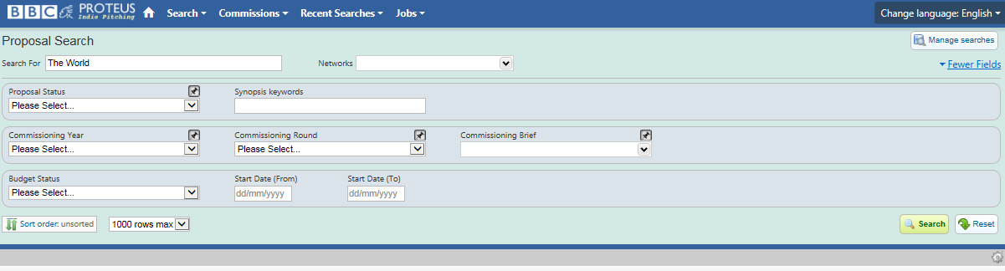
Click on the arrows to the right of each field to reveal the options available:

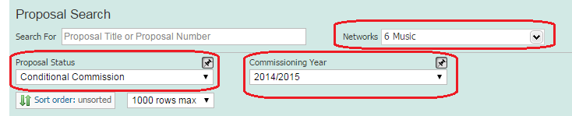
For example, the options selected below will display results of all your proposals at Conditional Commission status in the commissioning year 2014/2015 for 6 Music only:

If you leave the “Proposal Status” field blank, results will be displayed for all proposals at any status in the 2014/2015 year for 6 Music only.

6.1 Personalise the Search Screen
To avoid having to constantly click “More Fields” to display the additional fields that you regularly use to filter you search results, personalise your proposal screen by using the “Pin” option.
Hover above the fields you use frequently, a pin symbol will appear on the right above the drop-down arrow.

Click on the “Pin” symbol:
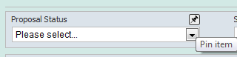
This field will now remain pinned at the top of the screen each time you log into Proteus. This avoids having to continually open “More Fields” to access the fields:
To close the “More Fields” panel, click “Fewer Fields”:
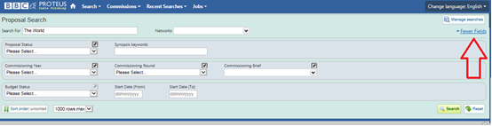

6.2 Customise Search Results
Once you have completed a proposal search, default information about a proposal is displayed on the search results screen. See screen below.
You can customise this screen so that it displays columns of information about the proposal(s) which is more useful to you.
Click on the “Cog” symbol on the right hand side:
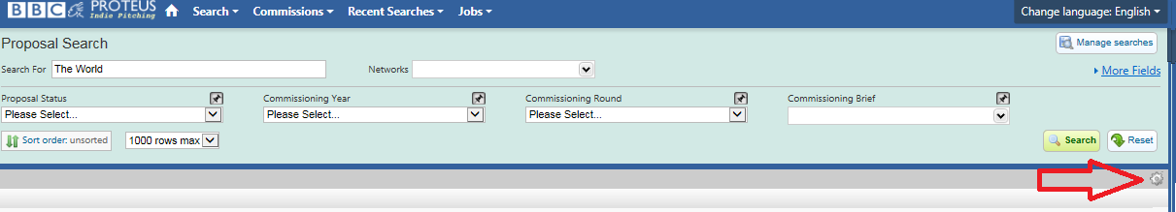
Click “Choose View”:
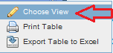

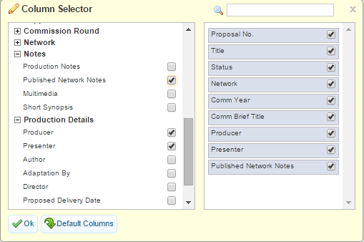
The column selector pop-up box is displayed:

This box allows you to select all the data columns which you would find useful to display on your search results screen.
The left hand side shows all the available data column headings that you can select. Click on the black “plus” symbol to reveal more options. You can also use the “Search” box to find the column(s) you want.
Tick the box to select a data column. Your selection will appear on the right hand side.
To change the column order, click and drag the grey boxes up or down.
Click “OK.”
The data columns you have selected will be displayed on your search results page.
To change the column order, you can either drag the columns headers left or right (a red line will indicate where it can be dropped) or via the “Cog”, as explained above.
TIP: Once your search results screen displays the columns you have selected, make sure you run a fresh proposal search straight away so that Proteus stores your column selections. These columns will be there next time you log in, instead of the default column settings.

7 Edit a Proposal after Submission
Once a proposal is at “Network Received” status only the network can edit it or change its status (see Status section of this guide).
If an urgent amendment needs to be made, contact the relevant network. They may agree to change the status to “Re-Request” so that the proposal can be amended and resubmitted.
It is not possible to make further changes to a proposal which is at “Conditional Commission” status. If any changes are agreed with the network they will amend the records in Proteus to reflect this. The record remaining in Proteus is an accurate reflection of the proposal at the time of commissioning.

8 Delete a Proposal
It is not possible to delete a proposal once it has been saved.
However, if the proposal is still at “Departmental” status (i.e. it has not yet been submitted to the network), the fields can still be edited and are therefore reusable by overwriting the existing information. Fields cannot be edited if the proposal is at “Network Received” status (i.e. the “Submit to Network” button has been pressed).
Please note, it is not possible to change the “Supplier” field (i.e. production area) which is dictated by your login, or the “Guide Price per Episode” field which is managed by the relevant network.

9 Printing

9.1 Print an Individual Proposal
To print individual proposals from “Proteus Commissioning”, you will first need to search and display the proposal in full.
A quick way is to first check if the proposal is listed in the “Recently Viewed” section on the “Home” page. If it is, then simply click on the title to reveal the proposal details:
If the title is not listed in the “Recently Viewed” section, click “Proposal Search” located in the blue panel. Enter your search criteria and once the search result is displayed, click on the proposal title to reveal the proposal (for more information see the “Search for Existing Proposal” section).
To print the proposal, click “File” and select “Print” from the browser toolbar:
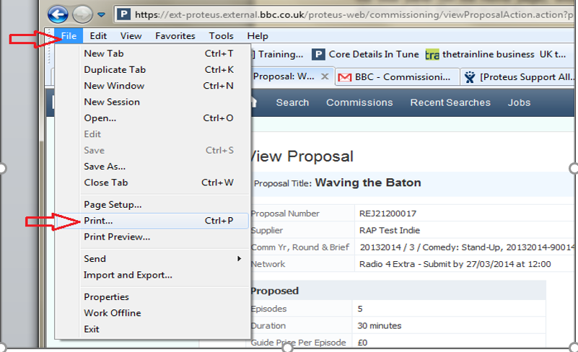

If using Chrome browser, right click anywhere on the proposal screen and select the “Print” option.

9.2 Print Multiple Proposals
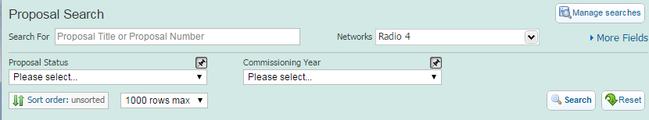
To batch print multiple proposals, you will first need to search for the proposals.
On the homepage, click “Proposal Search” and enter the relevant search criteria:

The search results will display a list of proposals.
To select specific proposals, click the tick box to the left of each proposal number (click the box again if you want to deselect).

To select ALL proposals in the list, click the top left tick box (click this box again if you need to deselect).
Click “Batch Actions” button, located at the bottom right of the screen.
(NB. proposals will not be printed at this point).
(For information: “Print Results” button will print the search results list as it appears on the screen and “Export Results” will export the results grid into a CSV file which can be saved as an Excel doc).

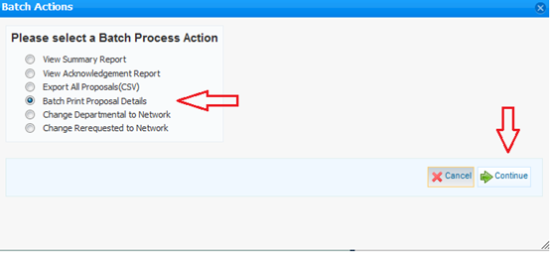
The “Batch Action” page will be displayed.
Select “Batch Print Proposal Details”, click “Continue” and this will print the selected proposals in full:

The option to “Export All Proposals (CSV)” allows the proposal details to be viewed in Excel. This file can be printed or saved.

However, please remember that your proposals will always be available to view in Proteus at any point now and in the future. Saving these files outside the system is duplication.

10 Proposal Reports
Follow the same steps as “Print Multiple Proposals”.
The “Batch Process” screen will be displayed.
The first and second options on the left hand side enable you to generate a pre-defined “Summary” or “Acknowledgement Report”.
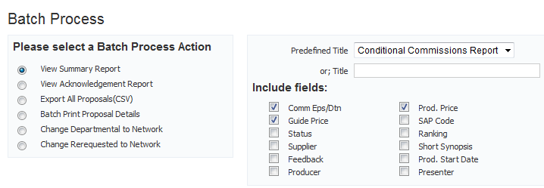
The options in the right hand panel enable you to choose which data to display in a report:

Once a report option has been selected, click “Continue” for the report to be displayed.

TIP: the reports you generate can be viewed again at any point by simply clicking on the “Jobs” option on the top blue menu bar and clicking the relevant report.
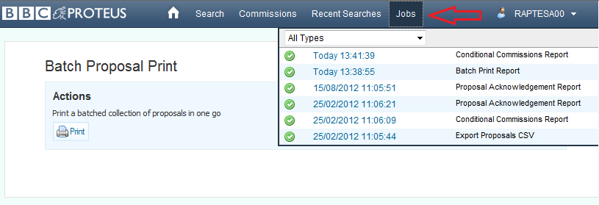

11 Commissioning Round Results
The commissioning network will publish a commissioning round timetable. This will include the date when the results are due to be released. This information can be found in the “Commissioning Guidelines” document relating to the specific round or it may be published on the BBC Commissioning website:
https://www.bbc.co.uk/commissioning/radio/stations-sounds/
https://www.bbc.co.uk/commissioning/radio/current-commissioning-opportunities/
On results day, you will need to access Proteus and search for your proposal (see “Search for Existing Proposal” and “Customise Search Results” sections of this guide).
When the search results are displayed, look at the “Proposal Status Description” column.
The proposal status may say “Shortlisted”, “Conditional Commission”, “Rejected” or “Re-Request.”
Click on the proposal title to access the proposal. The network may have entered feedback. If you have customised your “Search Results” screen, you will see the feedback on this screen too.
If you submitted multiple proposals, you can conduct a search on that particular round and network to display a full list of what you submitted, instead of searching for individual proposals.
If you need to discuss the proposal results status/feedback, please contact the relevant Network.

12 Proposal Budget
Most proposals are conditionally commissioned with a fixed price offer.
However, on occasion, you may be required to submit a budget. If this is the case, you will be contacted and asked to submit information via the budget template in Proteus.
The proposal will display a “Budget Request” notification link. Click on the link, complete the details and click “Submit”.
If the budget is challenged, you may be required to resubmit the information. Proteus will show a “Budget Re-Requested” notification. This will allow you to edit the budget details to reflect what has been agreed, and resubmit the information.
Any queries should be directed to the relevant network Business Affairs representative:
https://www.bbc.co.uk/commissioning/radio

13 Logging Out
To log out, go to the top menu bar, click on your username and select “Log Out”. You may then close the browser window:
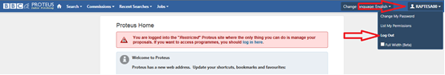

14 Support
Becoming a Supplier:
https://www.bbc.co.uk/commissioning/radio/commissioners/becoming-a-supplier/

Proteus Team:
The Proteus team work Monday to Friday office hours. Response times may vary depending on staffing. Please refer to the Becoming A Supplier page (see link above) before contacting the team.
E-mail: proteus.support@bbc.co.uk
Network Contacts:
https://www.bbc.co.uk/commissioning/radio/stations-sounds/

